Bug Report

TC - 001

Issue - ‘Learn More’ button isn’t navigating to the intended page

Reproducing Steps:

* Go to the homepage
* Scroll down to the services section
* Click the ‘learn more’ button

Env: production

Priority: p1

Severity: minor

Screenshot/Video: [Video](https://drive.google.com/file/d/1WeQt4bNppXFva68-TMpXa_d1rL1AAnIA/view?usp=sharing)

Responsible QA: Rafid

Expected: The button should navigate to the services page or appropriate section

TC - 002

Issue – Dropdown links under ‘CT Drilling’ in Header not navigating to correct pages

Reproducing Steps:

* Go to the homepage
* Click on the dropdown button Under CT Drilling
* Click on the links in the dropdown

Env: production

Priority: p1

Severity: minor

Screenshot/Video: [Video](https://drive.google.com/file/d/1WhnEQZPD0FmhQpwCpL1FGJ9wfNzWvGCg/view?usp=sharing)

Responsible QA: Rafid

Expected: Dropdown links will navigate to the correct section or page

TC - 003

Issue – Social media icons in footer not navigating to respective platforms

Reproducing Steps:

* Go to the homepage
* Scroll down to the footer section
* Click on the social media icons

Env: production

Priority: p3

Severity: minor

Screenshot/Video: [Video](https://drive.google.com/file/d/1WjEAerjrP9e7ZDf2FS7VWR8w9aZdmwgR/view?usp=sharing)

Responsible QA: Rafid

Expected: Should navigate to the respective platforms like facebook, Instagram etc

TC - 004

Issue – Footer logo does not match header or website logo

Reproducing Steps:

* Go to the homepage
* Scroll down to the footer section

Env: production

Priority: p4

Severity: minorScreenshot/Video:

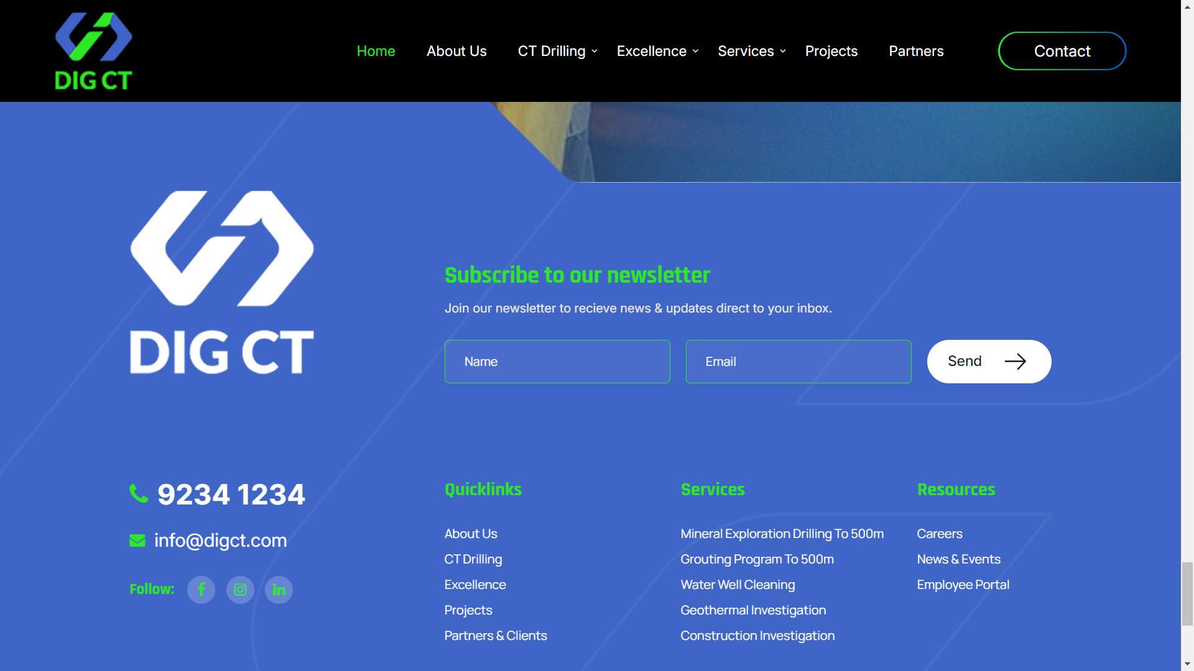

Responsible QA: Rafid

Expected: Logo should be same everywhere in the website